Student Performance Prediction System

Project Id: AIML-5

Name : Member1 (Team Leader)
Class Roll Number:
University Roll Number :
Section and Group:

Name : Member2
Class Roll Number:
University Roll Number :
Section and Group:

- Problem Description 3
- Architecture 4
- Models model 5
- Evaluation metrics used 6
- Preliminary Results and Visualizations 7
- References 8

- Problem Description
The Student Performance Prediction System is a Python-based machine learning application developed to automate the analysis and prediction of student academic outcomes. It streamlines the process of collecting student data, training predictive models, and generating performance insights while maintaining accuracy and efficiency. Using core concepts of Machine Learning such as data preprocessing, feature selection, regression/classification algorithms, model evaluation, and visualization libraries, this project minimizes manual effort in identifying at-risk students and supports data-driven academic decision-making.

- Architecture

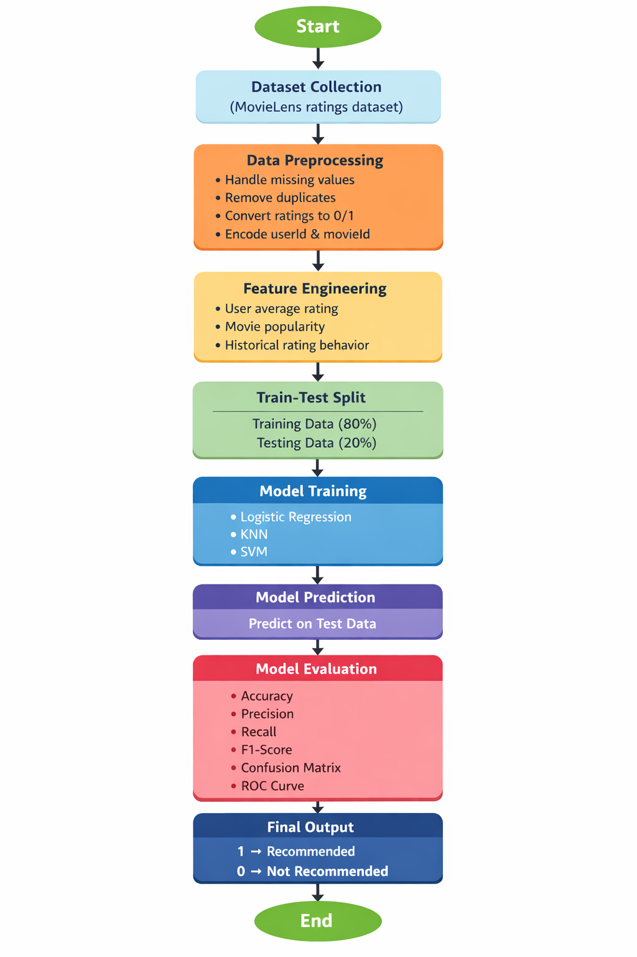
Fig.1 Sample flow diagram.

- Models Used(Applied/ Planned) Give a brief introduction of the models used

- Evaluation metrics used

5. Preliminary Results and Visualizations

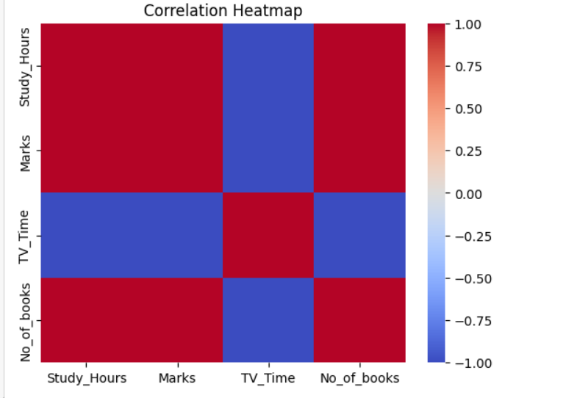

Fig.2 Heatmap showing corelation.

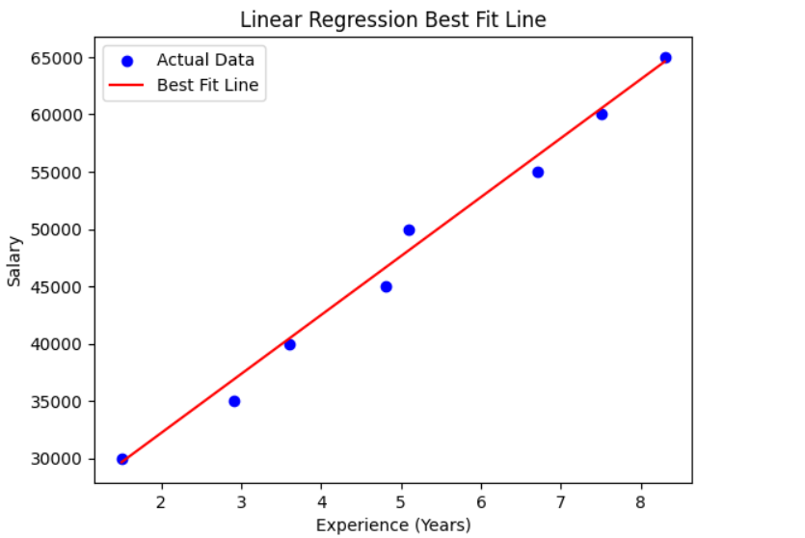
Fig.3

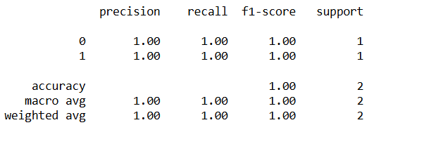

6. References:
Books:
- Let Us Python – Yashavant Kanetkar

Online Resources:
  - GeeksforGeeks – https://www.geeksforgeeks.org/
  - TutorialsPoint – https://www.tutorialspoint.com/cprogramming/index.htm
  - Stack Overflow – https://stackoverflow.com

